**Khulna University of Engineering and Technology**

**Department of Computer Science & Engineering**



Course No - CSE 2100

Course Title- Software Development Project-I

Project Name:- Salat Assistant

**Supervised by Developed by**

Md. Abdul Awal Md. Masum Billah

Lecturer, Roll-1207002

Department of Computer Science & Engineering Md. Mehadi Hassan

Khulna University of Engineering & Technology, Roll-1207038

Khulna .

-----------------------------

Signature

**Acknowledgement**

All the praises and greatness goes to Almighty Allah Who has given us chance to develop a project by using java language.

We wish to express our sincere thanks to our supervisor Md. Abdul Awal, Professor, Department of Computer Science and Engineering, KUET. His enthusiastic supervision and endless encouragement helps us to reach ultimate goal. With his continuous guidance and incomparable ingenuity, he inspected the project development which encourages us taking the decision for next step and led us to the achievement. We express our indebtedness and deepest gratefulness to him.

We would also like to acknowledge to our respected seniors, friends for their kind association.

Any constructive comments, suggestions, criticism from teachers as well as seniors will be highly appreciated and gratefully acknowledged.

“Authors”

**1.1 Introduction**

The world is now on the base of computer .Computer is related to two basic parts, software and hardware. From the beginning of computer different kinds of software are developed to enhance the capability of computer.

When Computer user worked in computer he generally forget the prayer time, Sunrise and Sunset time, Iftar and Sehry time. And also needs to remind prayer time.

On the basis of prayer assistant for Computer user, we developed a project namely Salat Assistant in java language. It is a simple project but every Computer user can use it.

**1.2 Objectives:**

* Become familiarization with Java language and its features.
* To develop a software project.
* To make a source of knowing daily prayer time.
* To make a source of knowing daily Sunrise and Sunset time.
* To make a source of enrich a Computer user knowledge about importance of Salat.

**1.3 Platforms:**

The Platform of our project is Java.

* 1. **Reason for choosing Java:**

**a. Platform independency:** Java is a platform independent language. So in every operating system java programs run efficiently.

**b. Object Oriented:** Java language is fully object oriented. It supports some advance features like Inheritance, Polymorphism and Encapsulation.

**c. Dynamic:** Java has capability to create new user defined classes & methods dynamically.

**d.** **Multithreading:** Java supports multithreading, which enable to run more than one program concurrently.

**Description of project**

**2.1 Requirements**

As we developed the game on java language .We used the following parts:

1. Eclipse
2. Java RuntimeSE_7U
3. Jdk-7-windows-i85

**2.2 Why “Salat Assistant”:**

Our project is an assistant based project. This is based on helping a Computer user .our project help him to see daily prayer time. When a desktop user doing his work he usually forget his prayer time but our project help him to remind him every wakt prayer time by giving him an Azan alarm. Our project also help him to know daily Iftar Sehry, Sunrise and Sunset time. Our project also help him to know daily date .Our project also help him to enrich his Islamic knowledge about Salat.

This is why we choose this project as our software development project.

**2.3 Features of “Salat Assistant”:**

* Firstly, there contains a mainframe with three options :

1. Settings
2. About
3. Help

* And also show the daily prayer time and date.
* For show daily prayer time and date you should press show button.
* For change alarm you should press change alarm button.
* For listen alarm you should press listen button.
* If you want to set this alarm you should press Set as Azan button.
* If you want to know masail of salat and importance of salat you should press about button.
* If you didn’t know how to work it then press help button.

**2.4 How to work this project**

* First you see the main window.

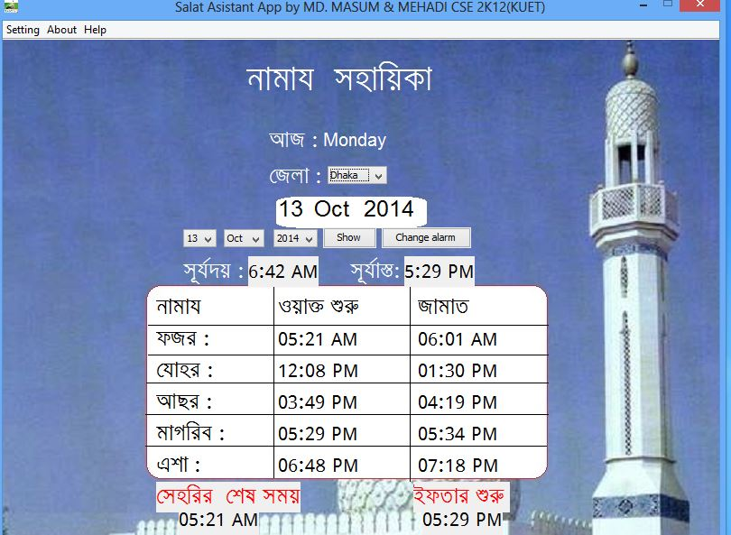

**Fig-1: Starting window**

* If you want to change the alarm the click change alarm button and a new window is coming and that is below:-

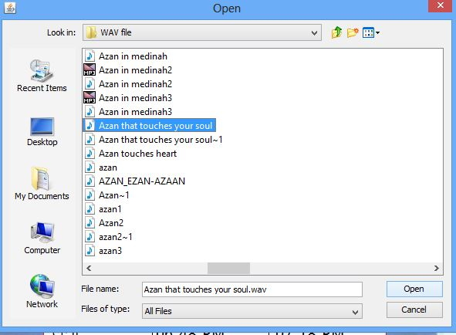

Fig-02: Alarm Changing Window

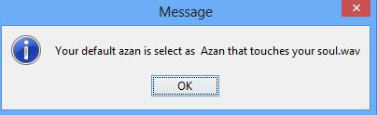

Fig -03: Alarm Changing Confirmation Message

* If you want to stop alarm then press stop azan button.

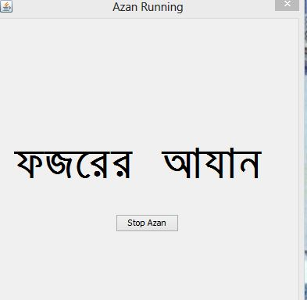

Fig-04: Azan running window.

* Following the above instructions, you can easily use this prayer time Assistant.

2.5 Behind the screen:

We developed the project by using java swing .We used the inheritance, polymorphism; encapsulation features to develop the project .We create each object in each class. The main logic is built in a class which controls the assistant. We used java library function. When we need to create the object, we just call the class.

Some important classes are given below:

1. StandardMain.
2. AzanClass
3. JMenuBar..
4. FileHandelling
5. SalatMasail

Some important java library we used

1. JFrame
2. JPanel
3. JLabel
4. JButton
5. JComboBox
6. JMenuItem
7. JDialog
8. Action Listener
9. Key Listener
10. Image

An example of our main class

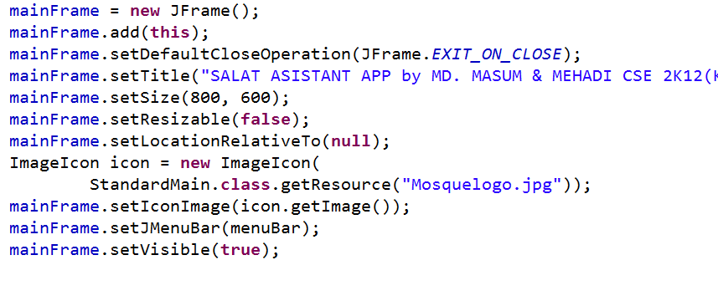

3.1 Limitations:

There are limitations of this Salat Assistant App like:-

* Prayer time are set only in Dhaka region.
* Only English Calendar are added in this .project.
* Bangla Font (Siyam Rupali) should be set up before using this App.
* This App are Comfortable for Bengali language learner.
* At the time of changing Alarm user can not listen alarm and stop .Alarm and Azan must be .wav file.

3.2 Future plan of “Salat Assistant”

Though we complete Salat Assistant, we will continue to develop it in coming days. Our plan is to make it more attractive to the user. For this we plan to do the following in future.

* The Salat Assistant will be updated so that it can be used any region in the world successfully.
* With English calendar Bangla ,Arabic Calendar will be added;
* Any language learner will able to use this App comfortably.
* Inside Salat Assistant options will be increased.
* The Salat Assistant app will be available for mobile.

3.3 Conclusion:

We have acquired a satisfactory knowledge on java. We have successfully brought a conclusion to our project “Salat Assistant”. While doing so many times faced a lot of difficulties .We overcame these obstacles by taking help from our supervisor as well as our seniors. The project may be small but it inspires us to do something bigger in future.

**3.4 Reference**

While accomplishing the project we take help from books, internet. Some of its examples are given below:

1. Java tutorial – Lynda.com java essential training
2. http://java 2d game/java2s
3. http://java - Changing JTable cell color - Stack Overflow.htm
4. Thinking in Java, 3rd Edition, Beta Bruce Eckel, President Mind View, Inc.
5. <http://docs.oracle.com/javase/1.4.2/docs/api/java/io/FileWriter.html>.
6. http:// docs.oracle.com/how to add image
7. Java How to program

Deitel & Deitel.